(OBSERVATION)
PROGRAM 4:

Newton-Raphson Method
Definition
The Newton–Raphson method is an iterative numerical technique used to find approximate solutions of equations of the form:
$$f(x)=0$$
Starting from an initial guess $x_{0}$, we improve the guess using:
$$x_{n+1}=x_{n}-\frac{f(x_{n})}{f^{'}(x_{n})}$$
Example — Solve $f(x)=x^{2}-5=0$
We know the true solution is $\sqrt{5}$, but let's find it using Newton–Raphson.
Step 1: Define $f(x)$and derivative
$$f(x)=x^{2}-5 \\ f^{'}(x)=2x$$
Step 2: Choose an initial guess
Let $x_{0}=2$.
Step 3: Apply the Newton–Raphson formula
$$x_{n+1}=x_{n}-\frac{f(x_{n})}{f^{'}(x_{n})}$$
Iteration 1
$$x_{1}=2-\frac{2^{2}-5}{2⋅2} \\ x_{1}=2-\frac{-1}{4} \\ x_{1}=2.25$$
Iteration 2
$$x_{2}=2.25-\frac{\left(2.25)^{2} − 5\right.}{2(2.25)} \\ x_{2}=2.25-\frac{5.0625-5}{4.5} \\ x_{2}=2.25-\frac{0.0625}{4.5}x_{2}≈2.2361$$
Iteration 3
$$x_{3}=2.2361-\frac{\left(2.2361)^{2} − 5\right.}{2(2.2361)} \\ x_{3}≈2.2360679$$

Final Approximation
$$\sqrt{5}≈2.2360679$$
After only 3 iterations, the result is accurate to 7 decimal places—showing how fast the Newton–Raphson method converges

RECORD:

Experiment: Root of given Equation using Newton-Raphson method Aim:
To find the root of a given nonlinear algebraic equation using the Newton–Raphson Method.
Definition:
The Newton–Raphson Method is an iterative numerical technique used to find successive approximations to the root of a real-valued function f(x)=0.

Theory:
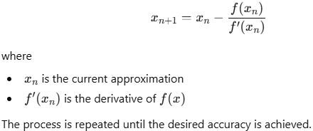
The method is based on the Taylor series expansion of the function about an initial approximation.

The iterative formula is:

Algorithm:
  - Define the function f(x) and its derivative f′(x).
  - Choose an initial approximation x0 .
  - Apply the Newton–Raphson formula:

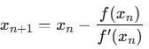

  - Repeat the process until convergence.

  - Print the root.

  - stop

Flowchart:-
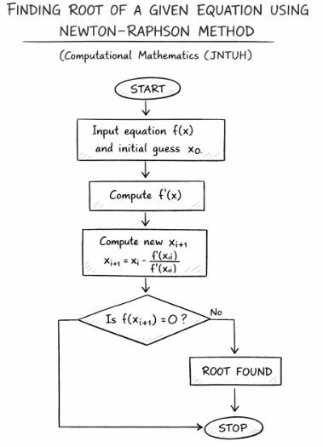

Example problem
Find the root of the equation: f(x)=x3-2x-5=0

Python Program (Newton-Raphson method)
def f(x):
return x**3 - 2*x - 5

def df(x):
return 3*x**2 - 2

# Initial approximation
x0 = 1
tolerance = 0.0000001
max_iter = 20

x = x0

print("Iteration\t x value\t\t f(x)")

for i in range(max_iter):

x_new = x - f(x)/df(x)

print(i + 1, "\t\t", x_new, "\t", f(x_new))

if abs(x_new - x) < tolerance:
print("\nConverged at iteration:", i + 1)
break

x = x_new

print("\nRoot of the equation is:", x_new)

output:

Iteration x value f(x)
1 7.0 324.0
2 4.76551724137931 93.69459871253434
3 3.3487027594802825 25.854311546130113
4 2.53159964100251 6.161814570048772
5 2.1739158849392317 0.9258996472874879
6 2.097883686441764 0.03726200559588211
7 2.0945577158500575 6.958408173041164e-05
8 2.0945514815642077 2.4422508460020254e-10
9 2.0945514815423265 -8.881784197001252e-16

Converged at iteration: 9

Root of the equation is: 2.0945514815423265

